**📊 Customer Segmentation Using RFM Analysis in Power BI**

**🔍 Project Overview:**

This project aims to segment customers based on their purchasing behavior using the RFM (Recency, Frequency, Monetary) model. Using Power BI, we visualized and analyzed customer patterns across various segments to help businesses tailor marketing strategies, improve retention, and boost profitability.

**🎯 Objectives:**

* Segment customers using RFM analysis.
* Identify loyal, high-value customers and those at risk of churning.
* Enable data-driven marketing and customer engagement strategies.
* Visualize insights with interactive dashboards.

**🛠️ Tools & Technologies:**

* **Power BI** – For data visualization and dashboard creation.
* **Excel Dataset** – Source data containing customer transactions.
* **DAX** – To calculate RFM scores and create KPIs.

**📌 Methodology:**

**1. Data Preparation:**

* Imported customer transaction data (ID, date, amount, country).
* Cleaned and transformed data for RFM metric calculation.

**2. RFM Metrics Calculation:**

* **Recency**: Days since last purchase.
* **Frequency**: Number of purchases in the past year.
* **Monetary**: Total amount spent by the customer.

**3. Scoring:**

* Assigned R, F, and M scores (1-5 scale).
* Combined to form an **RFM Score** (e.g., 555 = most valuable).

**4. Customer Segmentation:**

Mapped RFM scores to defined customer segments:

* **Champions**
* **Loyal Customers**
* **Potential Loyalists**
* **New Customers**
* **Promising**
* **Need Attention**
* **At Risk**
* **About to Sleep**
* **Hibernating**
* **Lost**
* **Can't Lose**

**📈 Key Dashboards:**

**🔹 Customer Segmentation [Asia]**

* **Customer Count by Segment** (bar & treemap)
* **Percentage Distribution by Segment**
* **Top segments**: Lost (4.3K), Loyal Customers (3.2K), Potential Loyalists (2.1K)
* **Monetary Value**: Highest among Champions (~238.7M)

**🔹 RFM Analysis**

* **Recency**: Champions made purchases just 7 days ago on average.
* **Frequency**: Champions placed ~40 orders per year.
* **Monetary**: Champions generated the highest revenue.

**🔍 Insights:**

* A significant portion of customers fall under the **“Lost”** category – an opportunity for re-engagement campaigns.
* **Champions and Loyal Customers** account for the highest revenue — these should be prioritized for rewards and retention programs.
* **At Risk** and **Hibernating** segments require reactivation strategies.

**✅ Key Takeaways:**

* RFM Analysis is a powerful method for understanding customer behavior.
* Segment-based strategies can help businesses boost retention, reduce churn, and increase lifetime value.
* Power BI enables interactive storytelling for impactful business decisions.

DASHBOARD:

Page -1

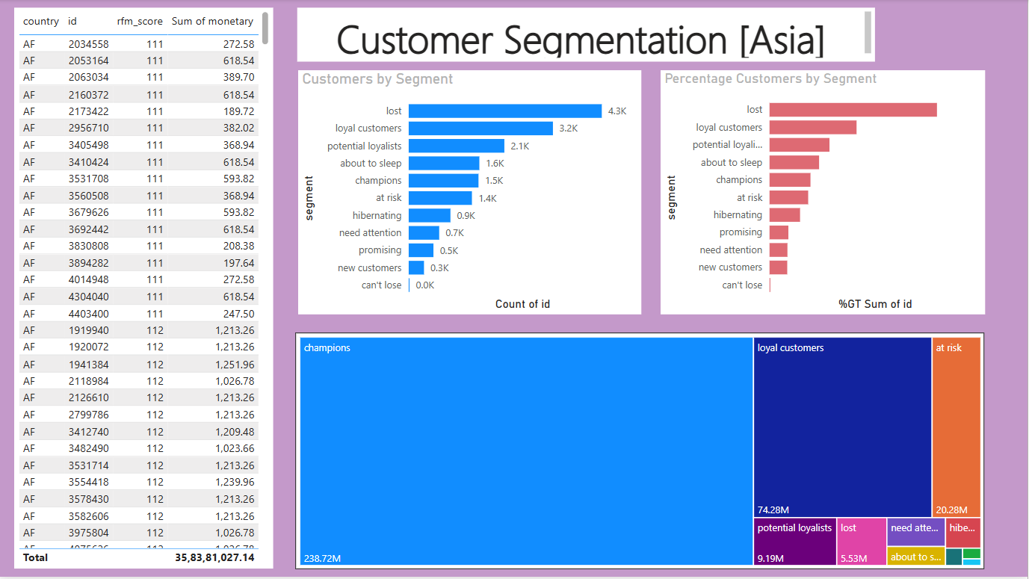

Page -2:

